**CH 245: ORGANIC CHEMISTRY I LABORATORY (Fall 2019)**

**Title:**

1. **Purpose: (1 point)**

**To synthesize methyl m-nitrobenzoate from methyl benzoate and purify crude compound with recrystallization.**

1. **Drawing of structure of the main compound or balanced chemical equation if synthesis is performed: (1 point)**

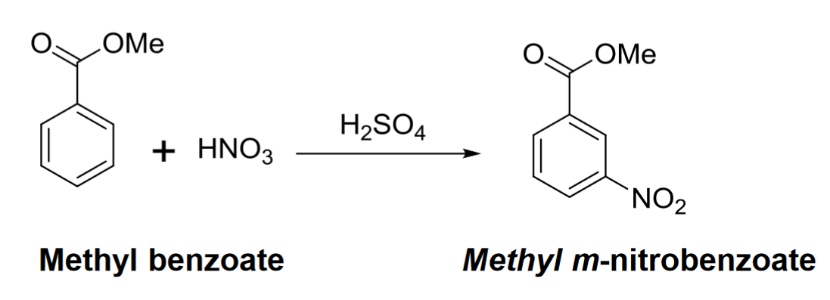

**3. Reagents and the major product (up to 5 points)**

|  |  |  |  |  |  |  |
| --- | --- | --- | --- | --- | --- | --- |
| **Name** | **M.W.**  (0.5 pts) | **Density**  (0.5 pts) | **Amount (grams/mL)**  (0.5 pts) | **Moles**  (0.5 pts) | **Hazards/Precautions**  **(MSDS data) and melting point or boiling point** (2 pts) | **Role of the reagent\*** (1 pts) |
| Methyl Benzoate | 136.15 | 1.080 g/cm3 | 1.4 grams / 1.3 mL | 0.010 | Combustible, harmful if swallowed | Reactant |
| Nitric Acid | 63.02 | 1.40 g/cm3 | 1 mL | 0.022 | Corrosive, eye damage, respiratory irritation, organ toxicity. | Reactant |
| Sulfuric Acid | 98.07 | 1.840 g/cm3 | 4 mL | 0.075 | Very strong acid, corrosive, eye damage, respiratory irritation, organ toxicity. | Catalyst |
| Methanol | 32.04 | 0.791 g/cm3 | 2 mL | 0.049 | Flammable, toxic, fatal or cause blindness if swallowed. | Solvent/  Washing |
| Methyl  m-nitrobenzoate | 181.15 | 1.301 g/cm3 | 1.81 g | 0.010 | May be harmful if inhaled or swallowed. May cause skin and eye irritation. | Product |

**For Role of the reagent*, Choose from the following options:**

**Reactant, Product, Solvent, Drying agent, Catalyst**

1. **Calculations: (1 point)**

Show each calculation for moles of reagents and for theoretical and actual yield. Fill in the box with the limiting reagent and theoretical yield:

Methyl benzoate

The limiting reagent is

1.81 grams m-nitrobenzoate

The theoretical yield is

$$0.010 \text{mol methyl benzoate}*\frac{\text{1 mol m-nitrobenzoate}}{\text{1 mol methyl benzoate}}*\frac{\text{181.15 g m-nitrobenzoate}}{1 \text{mol m-nitrobenzoate}}=1.81 \text{grams m-nitrobenzoate}$$

**5. Procedure (up to 2 points)**

|  |  |
| --- | --- |
| **Procedure** | **Observations and Lab Data** |
| A summary of the procedure done with bullet points) | Color changes, exothermic or endothermic reactions, gas generation, etc.; tare weights for flasks, etc. |
| * Place 3 mL (5 g) of concentrated sulfuric acid in a 50 mL Erlenmeyer flask and add a stir bar. * Cool to 0°C, and add 1.3 mL (1.4 g) methylbenzoate, stirring. * While maintaining internal temperature of 5-15°C, add drop by drop a cold mixture of 1 mL conc. sulfuric acid and 1 mL conc. nitric acid. * Swirl/stir solution during addition for 10 min after all the acid has been added. * Pour the reaction mixture, with stirring, onto 10g of cracked ice bath to precipitate crude methyl m-nitrobenzoate. * Collect the product with vacuum suction with a Buchner funnel. * Wash the product on a filter paper with two or three 3 mL portions of water to remove acids. (Aq waste) * Wash the product with two 1 mL portions of cold methanol and dry for 5 minutes. (organic waste) * Take weight of crude product * Remove a few crystals for recrystallization and TLC. * Take crude product in 25mL Erlenmeyer flask and add 2.5 mL methanol per gram of crude product. * Add two boiling stones and heat mixture over hot plate until all solid dissolves. * Cool flask to room temperature. * Put flask over ice bath for 5 minutes. * Filter mixture using Buchner funnel and vacuum. * Wash the solid with two 1 mL portions of ice-cold methanol and allow solid to dry. * Take weight of recrystallized solid. * Prepare three small beakers. * Add methyl benzoate to first, crude product to second, and recrystallized product to third. * Add small quantity of dichloromethane to dissolve. * Take a TLC plate and add lines one cm from top and bottom. * Mark three dots with a pencil on one of the lines. * Spot each of the three compounds on the TLC plate and mark spots. * Put a mixture of 80% hexane and 20% EtOAc in the TLC bottle. * Put a filter paper in the TLC bottle. * Put the TLC plate and let the solvent run up to the top line. * Take out TLC plate and let it dry in air. * Visualize under UV lamp and mark spots. * Calculate Rf of each spot. |  |

**6.** Results; include actual yield in grams and % yield.

**Results (need to get signed by instructor or TA):**

**Weight of crude m-nitrobenzoate – 18.00 – 16.82 = 1.16 grams**

**Weight of recrystallized product – 24.77 – 24.00 = 0.77 grams**

**Percent yield = 0.77/1.81 = 42.5%.**

**TLC:**

**Starting material – A: 2.5/4 = 0.625.**

**Crude product – Bcrude: 1.1/4 = 0.275, Bdesired: 1.5/4 = 0.375**

**Recrystallized product – C: 1.5/4 = 0.375**

**Conclusion**

I **accomplished** a synthesis of m-nitrobenzoate from methyl benzoate, purified the crude m-nitrobenzoate product, and verified its identity with TLC. I **learned** how these reactions can create undesired products and the need for us to purify the products. Furthermore, I **learned** about how TLC can help us verify the identity of products obtained in reactions. An **issue** we ran into during the lab was the large amount of ice we used to recrystallize the product. It took a lot of washing and water to melt the ice in a reasonable amount of time, and we likely lost product through adding water. Therefore, I recommend in the **future** using less ice, or allowing the solution to cool down more, in order to limit the amount of solvent added. The **practical application** of this experiment is to synthesize nitrobenzene compounds, as well as learning how to purify compounds when reactions create undesired products in the real world, as well as verifying the identity of products.

**Post Lab Questions**

The role of sulfuric acid is to act as an acid catalyst for the reaction, letting nitric acid act as a nucleophile and eventually creating the nitronium ion that works as the electrophile for this reaction.

We would use ethanol.